This allows you to connect and work on your desktop computer in the office as if you were in your office while you are at home (or anywhere you have access to a PC and the internet)
Control Panel - All Control Panel Items – System - Get the name of the computer you want to connect to. (You’re desktop PC in your office; you need to get this name before you go home to set up the connection)

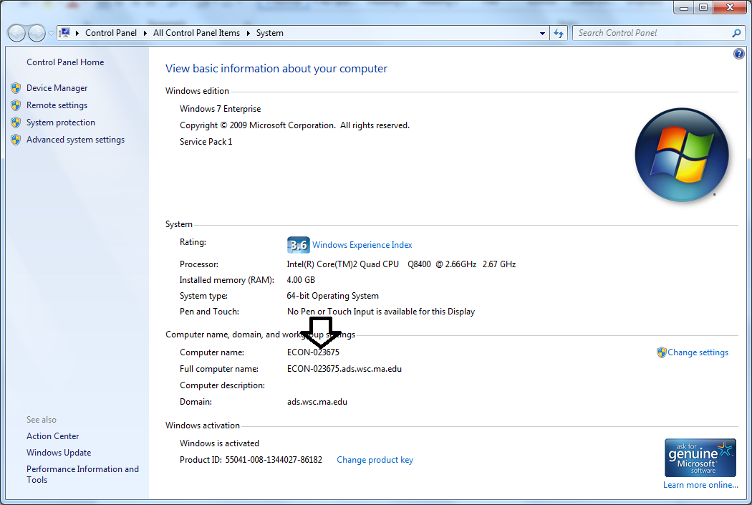

At Home,
Start – All Programs - Accessories – Remote Desktop Connection. 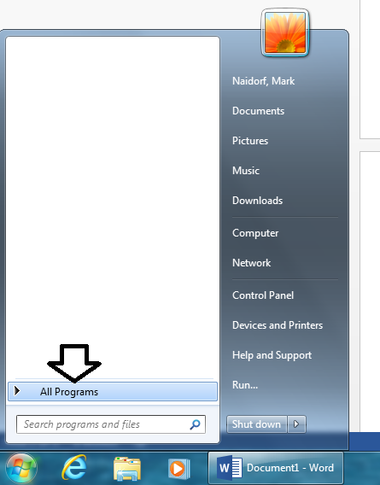

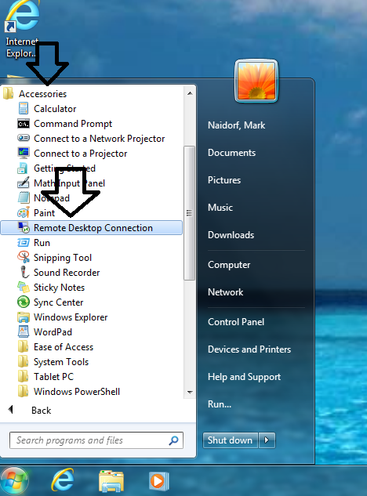

Click Show Options
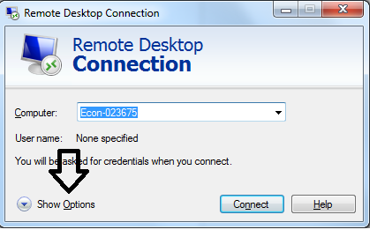

Type your computer name which you got from school and your username check remember me or not then save

.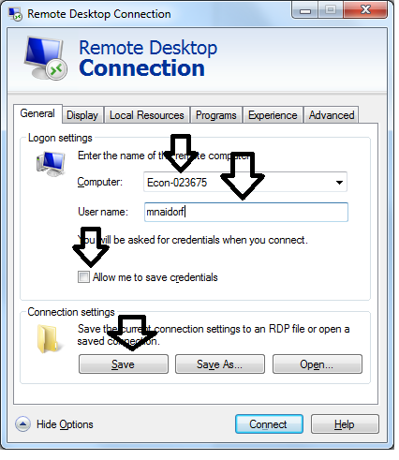
Go to Advanced tab and open Settings
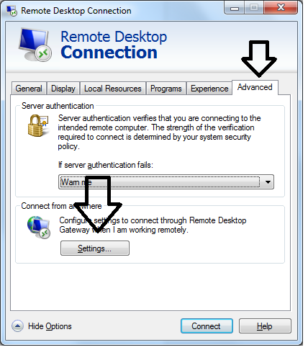
Go to “Use these RD Gateway ……… and type Gatekeeper.westfield.ma.edu and OK

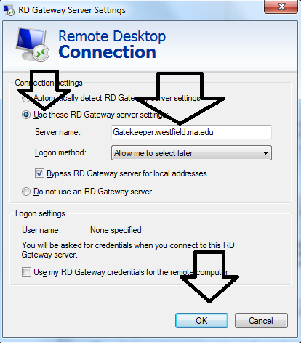
Click Yes if this window shows up.
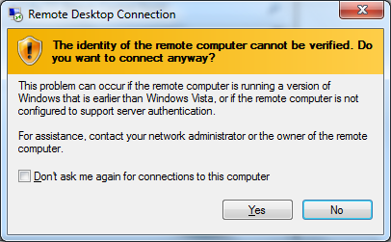

Enter username and password (same as desktop in your office) Remember or not. And OK
