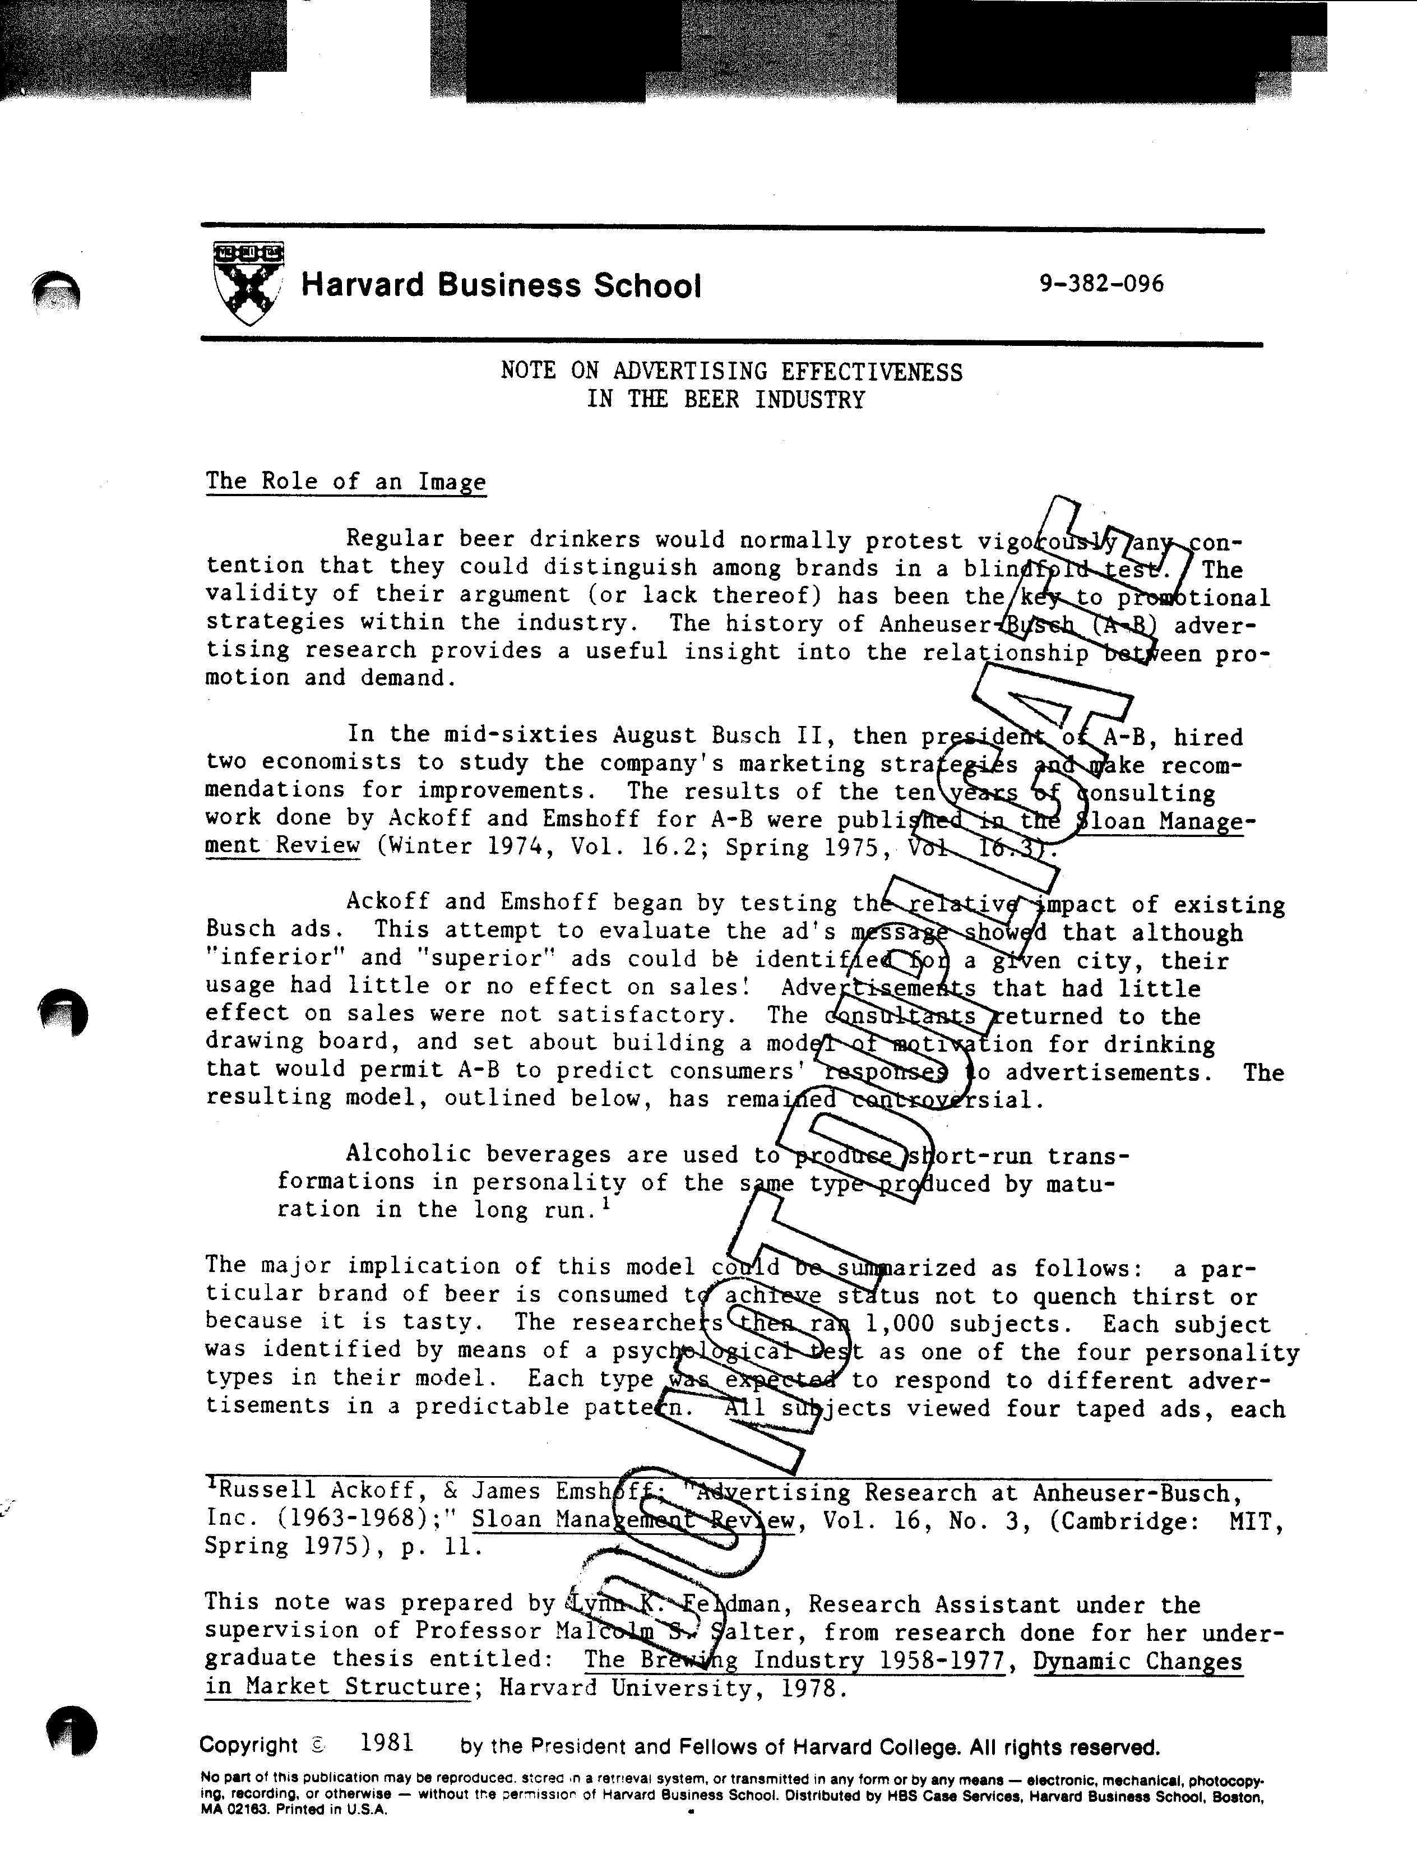

2 382-096

promoting a different made-up brand of beer. As expected, each subject responded overwhelmingly to only one of the four ads, the ad chosen varied with their personality type. The subjects then tasted the four beers advertised and chose their favorite. Eighty-five percent chose the beer whose advertisement appealed to their personality type.

An even more interesting result of the test was the effective.ness of all the ads. Each subject was asked if any of the beers tasted the same. One hundred percent responded that all four beers were different. The beer was all Budweiser, and had simply received phony labels. The image conveyed in the ad determined the consumer's response, in fact, it even modified his taste. Anheuser-Busch's promotional strategy was altered as a result of these findings.

The brewers' investment in brand name and product differentiation is thus essential for success. The premium image has been particularly effective because increases in real disposable income have brought about a desire for status or conspicuous consumption. (This assumes consumers cannot distinguish tastes - a reasonable assumption among most American beers of a given type.) The nationals have been the direct beneficiaries of consumer malleability, both because of the nationals' traditionally exclusive production of premium beers and also their more sophisticated marketing strategies. Only in the late seventies did regional breweries attempt to enter this market segment.

One side effect of this storage capability regarding investment in advertising is that small firms may easily overstate profits. Conventially brewers expense rather than capitalize the dollars spent on promotion. Were a reversal in this policy permitted, it would correct reported profits downward. This would explain how small, relatively inefficient although somewhat geographically isolated (and hence insulated) firms such as Lone Star and Olympia have been able to report such high rates of return.

Advertising Frequency and Intensity

In a second set of experiments, Ackoff and Emshoff tested the effects of advertising frequency and intensity. A-B tried "pulsing" ads having a vigorous campaign for one month, then no ads for the next month. Results showed that purchases fell off like the curve below after promotion had ceased. (See Figure 1).

Figure 1

Decline in Sales Following Pulsed Ads

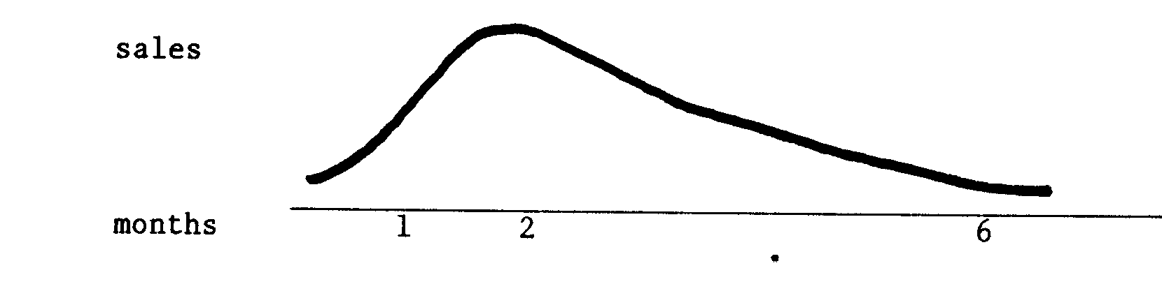
3 - 382-096

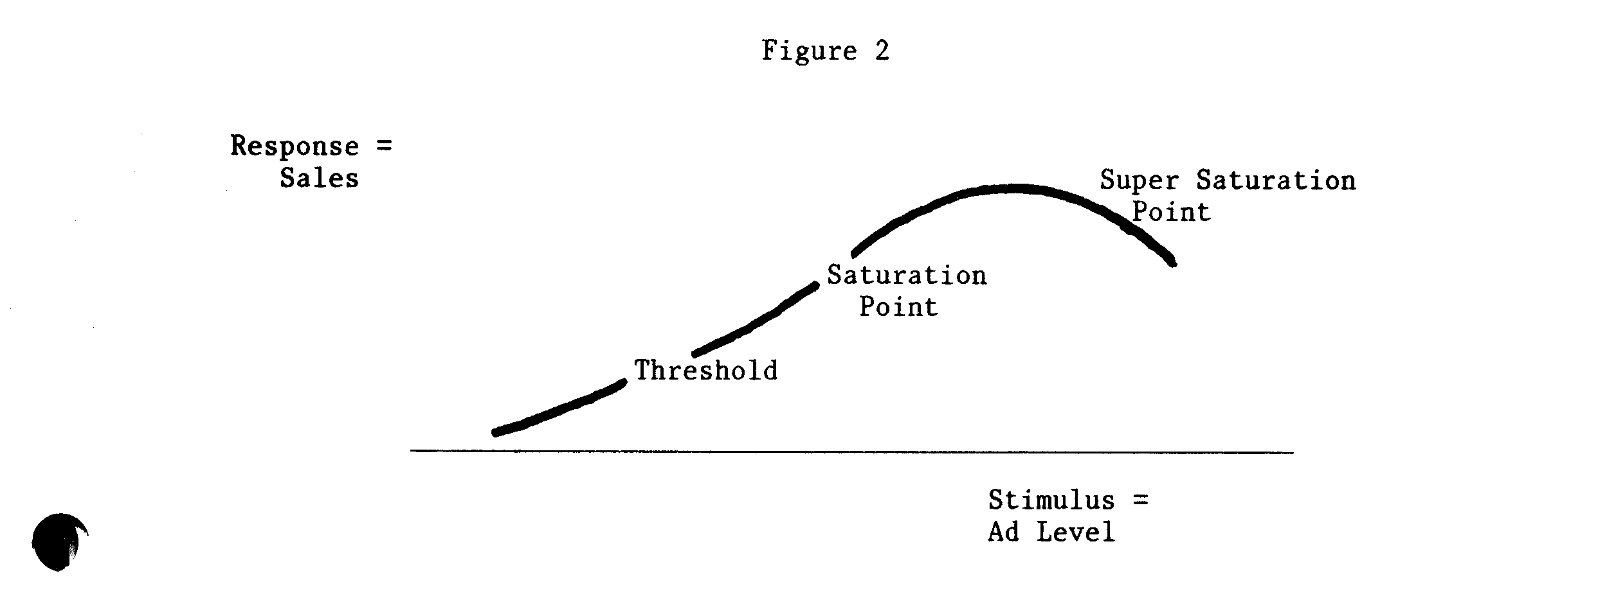
A unique aspect of the model was that the researchers believed that the public could be supersaturated with ad coverage and would respond by decreasing their purchases. (See Figure 2.) This was tested by selecting a small area of Budweiser distribution and increasing the advertising level by 400%. People were reported coming into taverns and package stores saying "give me anything but a Bud." Sales fell off as expected.

The thoroughness of the consulting research done by Ackoff and Emshoff gave A-B a big boost. Over the period 1963 to 1968, advertising expenditures per barrel fell from $1.89 to $.80. At the same time sales rose by 7.5 million barrels, representing a growth rate above both demand and industry sales growth rates during that period. Furthermore, this sales increase raised A-B's market share from 8.1 to 12.9, or an average of 12% per year.

Research by Allison and Uhl confirmed Ackoff and Emshoff's findings that consumers were unable to differentiate between brands on the basis of taste along.

Participants, in general, did not appear to be able
to discern the taste differences among the various beer brands, but apparently the labels, and their associations, did influence their evaluations. In other words product distinctions or differences, in the minds of the participants, arose primarily through their receptiveness to the various firms' marketing efforts rather than through perceived physical product differences. Such a finding suggested that the physical product differences had little to do with the various brands' relative success or failure in the market ... 1

'R.I. Allison and K.P. Uhl; "Influences of Beer Brand Identification on
Taste Perception;" Journal of Marketing Research, August 1965, pp. 36-39.

4 382-096

Other Factors

Marketing sophistication was not the only source of cost saving from which the nationals benefited. Geographical diversification permitted brewers more flexibility in promotional practices.

The national can afford to take a temporary loss or substandard profit because sales elsewhere offset the promotional costs in the local market in question.1

Promotional price cutting was prevalent during the sixties, and served to hasten the demise of marginal firms. The same flexibility insulated the national brewer from local market disruptions, such as a summer cold spell. Nationals would, however, reap the benefits of any hot spell which hit the same market. Fortune magazine described the bind in which small brewers found themselve s as follows.

When ... Anheuser-Busch sells Budweiser at a discount in San Antonio, many drinkers of Pearl and Lone Star, two local popular-priced beers, switch to Bud. Some of these converts keep drinking Bud even after the price goes up again. But Pearl and Lone Star cannot lure the Budweiser drinker by cutting their own prices, because Budweiser's premium image attracts and holds customers who are relatively unconcerned about price. Pearl and Lone Star can only steal customers from each other. And if one of them raises its price, it risks losing market share to the other, without making any impression on the Budweiser drinkers.2

The second benefit of operating nationally was related to consumer identification of brands. In a mobile society, the depreciation on brandname capital stock investments would be high if the consumer could move outside the brewer's market area. Even Coors suffered from an inability to serve demand on the East Coast stimulated by advertising. This meant national brewers received a higher return per promotional dollar. Local brewers had to continually educate new customers while losing old ones.

In 1964 all four of the Top 4 firms were among the ten brewers spending the most per barrel on advertising. (See Table 1 below.) By 1973, only one of the Top 4 remained in the list, and it was at the bottom. Per barrel expenditures declined while total advertising expenditures for each of these firms increased over the ten-year period. This adds weight to the argument that there are scale economies in advertising.

Drexel Burnham estimated that from 1965 to 1972, the nationals averaged between $3.50-$5.50 per barrel in total promotional expenditures.

¹Drexel Burnham & Co., 12/18/67, p. 3.
²Fortune magazine, November 1972, Vol. 86, No. 5, p. 103.

5 - 382-096

(These figures differ from Table 1 in their attempt to include point-ofpurchase promotion and other less easily quantifiable expenditures.) Schaeffer, one of the more successful regionals spent $9.40 per barrel in 1970 on promotion. Scherer in his book Economies of Multi-Plant Operations: An International Comparison Study, (Cambridge: HUP, 1975) claimed that not only did the nationals benefit from advertising scale economies, this was the only significant advantage to multiplant operation in the brewing industry.

The Late Seventies and Eighties

The downward trend in per barrel advertising expenditures was reversed in the past several years. As the nature of competition shifted from the "big boys" grabbing market shares from the unprotected local brewers to competition among five relatively equal large competitors, advertising reemerged as an important sales-increasing tool.

Falstaff was one of the leaders in adopting a multiplant strategy.

Table 1
NOTE ON ADVERTISING EFFECTIVENESS IN THE BEER INDUSTRY
Ten Brewers Spending the most per barrel on advertising each year
1964-1974

1964 1965 1966 1967 1968
Sales Sales Sales Sales
Company Amount Rank Company Amount Rank Company Amount Rank Company Amount Rank Company Amount Rank
 |  | SclitiLZ | $2.22 | 2 | Falstaff | $2.05 | 4 |  | Stroh | $1.87 | 15 | Carling | $2.02 | 5 | Miller |  |  | $1.83 |  |  | 8
 |  | Falstaff | 2.00 | 4 | National | 1.86 | 16 |  | Miller | 1.82 | 9 | Rheingold | 1.92 | 12 | National |  |  | 1.65 |  |  | 16
 |  | Carling | 1.98 | 5 | Sclilitz | 1.80 | 2 |  | Schlitz | 1.82 | 2 | Miller | 1.92 | 8 | Pearl |  |  | 1.51 |  |  | 17
 |  | Miller | 1.68 | 10 | Stroh | 1.74 | 14 |  | Ballantine | 1.74 | 12 | Pearl | 1.89 | 17 | Schlitz |  |  | 1.51 |  |  | 2
 |  | Hamm | 1.59 | 8 | Miller | 1.59 | 11 |  | Carling | 1.72 | 5 | Hamm | 1.71 | 9 | Stroh |  |  | 1.44 |  |  | 14
 |  | Anheuser-Busch | 1.59 | 1 | Ballantine | 1.49 | 7 |  | Pearl | 1.68 | 17 | National | 1.65 | 16 | Falstaff |  |  | 1.34 |  |  | 4
 |  | Pearl | 1.50 | 18 | Pearl | 1.43 | 17 |  | Falstaff | 1.68 | 4 | Schlitz | 1.59 | 2 | Carling |  |  | 1.33 |  |  | 7
 |  | Rheingold | 1.45 | 11 | Anheuser-Busch | 1.38 | 1 |  | National | 1.64 | 16 | Stroh | 1.57 | 15 | Olympia |  |  | 1.13 |  |  | 12
 |  | Ballantine | 1.29 | 7 | Hamm | 1.36 | 10 |  | Genesee | 1.35 | 19 | Genesee | 1.47 | 19 | Hamm |  |  | 1.11 |  |  | 9
 |  | Pabst | 1.29 | 3 | Pabst | 1.10 | 3 |  | Hamm | 1.35 | 8 | Ballantine | 1.40 | 11 | General |  |  | 0.99 |  |  | 19
 |  | 1969 |  |  | 1970 |  |  |  | 1971 |  |  | 1972 |  |  |  | 1973
 |  | Company | Amount | Rank | Company | Amount | Rank |  | Company | Amount | Rank | Company | Amount | Rank |  | Company |  |  | Amount |  | Rank
 |  | Miller | 1.83 | 8 | Miller | 2.12 | 7 |  | Miller | 2.59 | 6 | Miller | 2.07 | 7 |  | Carling |  |  | 1.82 |  | 11
 |  | National | 1.38 | 17 | Pearl | 1.56 | 18 |  | Carling | 1.82 | 8 | Pearl | 1.73 | 17 |  | Miller |  |  | 1.58 |  | 5
 |  | Heileman | 1.24 | 16 | National | 1.50 | 16 |  | Hamm | 1.81 | 9 | National | 1.48 | 15 |  | Pearl |  |  | 1.53 |  | 17
 |  | Schlitz | 1.20 | 2 | Hamm | 1.48 | 9 |  | National | 1.67 | 17 | Heileman | 1.40 | 11 |  | Hamm |  |  | 1.50 |  | 13
 |  | Falstaff | 1.00 | 5 | Falstaff | 1.48 | 6 |  | Ballantine | 1.42 | 16 | Carling | 1.39 | 9 |  | National |  |  | 1.33 |  | 15
 |  | Olympia | 0.96 | 12 | Ballantine | 1.41 | 17 |  | Olympia | 1.40 | 14 | Genesee | 1.32 | 16 |  | Falstaff |  |  | 1.14 |  | 6
 |  | Carling | 0.94 | 7 | Olympia | 1.30 | 12 |  | Genesee | 1.39 | 20 | Schlitz | 1.09 | 2 |  | Genesee |  |  | 1.09 |  | 16
 |  | Meister Brau | 0.92 | 24 | Carling | 1.30 | 8 |  | Heileman | 1.32 | 15 | Stroh | 1.07 | 8 |  | C. Schmidt |  |  | 1.08 |  | 12
 |  | Genesee | 0.92 | 19 | Genesee | 1.28 | 20 |  | Pearl | 1.30 | 18 | Olympia | 1.03 | 12 |  | Stroh |  |  | 0.96 |  | 8
 |  | Hamm | 0.91 | 9 | Schlitz | 1.20 | 2 |  | Falstaff | 1.23 | 7 | Atiheuser-Busch | 0.94 | 1 |  | Schlitz |  |  | 0.92 |  | 2
 | Source: Advertising Age and Frost & Sullivan study.

